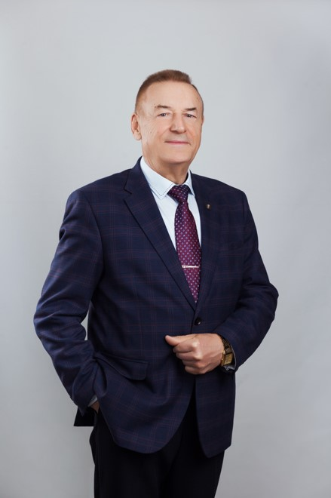

Chief Scientific Officer

Doctor of Agricultural Sciences, Professor,

Academician of the Russian Academy of Sciences,

Honored Scientist of the Russian Federation

GORLOV IVAN FEDOROVICH

Professor, Academician of the Russian Academy of Sciences I.F. Gorlov heads the work of one of the scientific directions of the National Research University Volga Research Institute for the Production and Processing of Meat and Dairy Products. These are not all his titles and regalia: he is a doctor of agricultural sciences, an honored Scientist of the Russian Federation, as well as a laureate of the Government of the Russian Federation in the field of science and technology, twice a laureate of the First Prize of the Ministry of Agriculture and Food of the Russian Federation, a laureate of the Volgograd region in the field of science and technology, awarded the medal "For Labor Valor" and 5 medals "Laureate VVC (VDNH)".

Ivan Fedorovich made a huge contribution to the development of Russian science, his innovative developments today have wide practical application in the production and processing of agricultural products. He has great efficiency, because he is also the chairman of the doctoral dissertation council, is a member of the editorial board of many specialized publications, and heads the Department of Food Production Technology at VolgSTU.

The fate and life path of this remarkable man are extraordinary, as is he himself. After graduating in 1971 from the Moscow Veterinary Academy named after K.I. Scriabin with honors, I.F. Gorlov began his career as the chief veterinarian of the Iskra state farm in the Uryupinsky district, soon became deputy. the director. His professionalism, organizational skills, and leadership talent were noticed and invited to the Volgograd Breeding and animal husbandry Department by the Deputy General Director.

Since 1995, a new milestone in his biography began. I.F. Gorlov headed the Volgograd Scientific Research Technological Institute of Meat and Dairy Cattle Breeding and Processing of Livestock Products of the Russian Agricultural Academy, and today it is the Volga Research Institute for the Production and Processing of Meat and Dairy Products of the Russian Academy of Sciences. In 1996, he successfully defended his doctoral dissertation and created his own scientific school, in 1998 he was awarded the academic title of professor. The year 2001 also became significant: Ivan Fedorovich was elected a corresponding member of RASKHN, and in 2005 he became an academician.

He does not stop there, constantly improving, keeping up with the times, looking for more effective methods of work. Under his experienced leadership, the Research Institute implements innovative, scientifically based principles, methods and mechanisms for improving the biological and technological qualities of livestock products at all stages of its production, has developed many recommendations, concepts, systems of agricultural production, as well as long-term plans for breeding and breeding work.

I.F. Gorlov managed to rally a team of like-minded and talented scientists around him. His staff has developed waste-free technologies for processing melons, oilseeds, legumes, and other crops and the production of biologically complete multi-purpose products based on them. A new beef breed of cattle, the Russian Brown, has been bred for the first time in Russia. Breeding work is successfully carried out in the field of sheep breeding, pig breeding and deep processing of livestock products. These unique ideas have already been adopted by more than 80 enterprises of the Lower Volga region, which makes their products more qualitative and competitive, meeting all the requirements of the modern market.

Work for I.F. Gorlov is an important component of his life credo.

High professionalism, the ability to find an approach to everyone, outstanding abilities – all this allowed I.F. Gorlov to gain authority not only among colleagues, agricultural producers, but also government structures.